**Sample Mainframe screen shot attached in the approved v3 0 mapping spec for TD01**

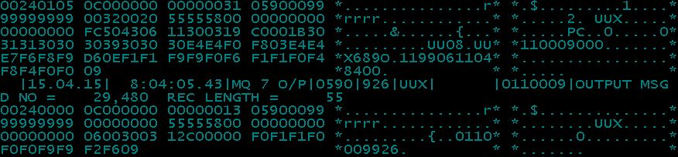

**OUTPUT from Accounting Hub / MQPUT message to be sent to TD01**

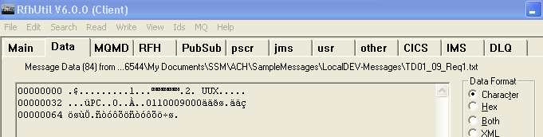

**OUTPUT from Accounting Hub / MQPUT message to be sent to TD01 – in Hex format for better reading**

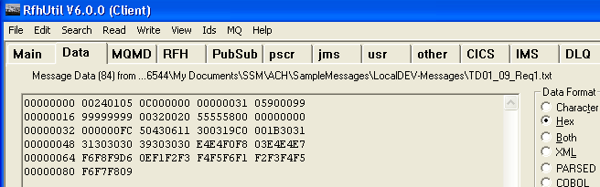

**Output message produced from Accounting Hub**



**Output in Hex format for better reading**

1. **0200000 Request.**

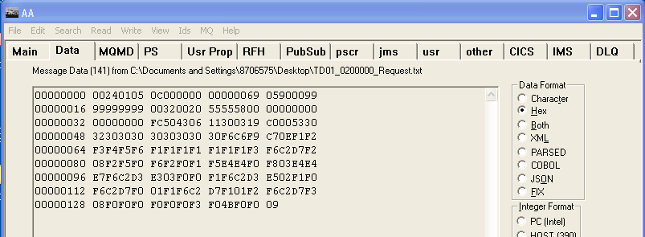

1. **0200052 Request.**

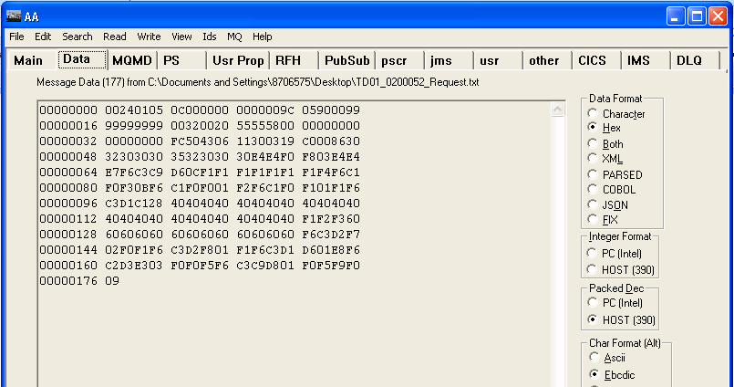

1. **0200003 Request.**

